|  |  |  |
| --- | --- | --- |
| **AD SOYAD** | **CENGİZHAN TOPÇU** | **KARABÜK ÜNİVERSİTESİ MÜHENDİSLİK FAKÜLTESİ**  **MEKATRONİK MÜHENDİSLİĞİ** |
| **NUMARA** | **2017010225048** |
| **İNTERNET TABANLI PROGRAMLAMA ÖDEV-5** | |

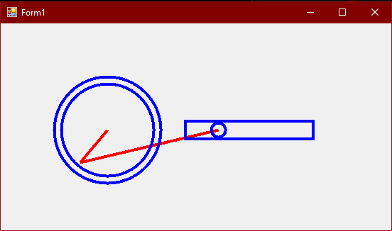

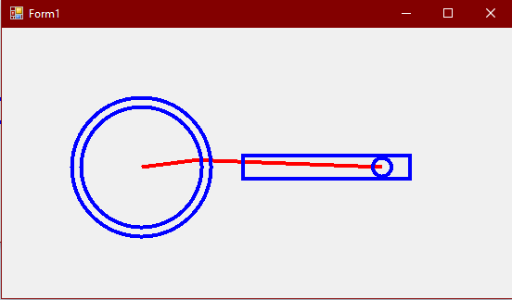

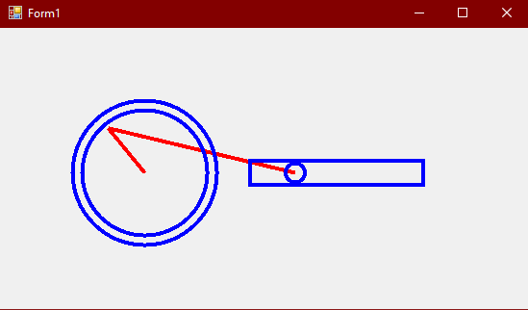

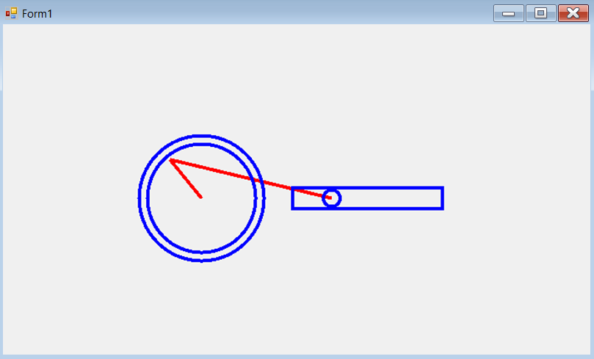

using System;

using System.Collections.Generic;

using System.ComponentModel;

using System.Data;

using System.Drawing;

using System.Linq;

using System.Text;

using System.Threading.Tasks;

using System.Windows.Forms;

namespace proje5

{

public partial class Form1 : Form

{

double L = 200;

double x, x1;

double y, y1;

double alpha;

double a, r = 60;

double acı = 0.105;

public Form1()

{

InitializeComponent();

}

private void Form1_Load(object sender, EventArgs e)

{

timer1.Interval = 30;

timer1.Start();

SetStyle(ControlStyles.OptimizedDoubleBuffer | ControlStyles.UserPaint | ControlStyles.AllPaintingInWmPaint, true);

DoubleBuffered = true;

}

private void timer1_Tick(object sender, EventArgs e)

{

alpha += 1;

Invalidate();

}

private void Form1_Paint(object sender, PaintEventArgs e)

{

e.Graphics.TranslateTransform(150, 150);

Pen pen = new Pen(Color.Red, 4);

Pen pen1 = new Pen(Color.Blue, 4);

x1 = x - (r * Math.Cos(alpha * acı));

y1 = y + (r * Math.Sin(alpha * acı));

a = y1 + Math.Sqrt(L * L - x1 * x1);

e.Graphics.DrawLine(pen, 0, 0, Convert.ToSingle(y1), Convert.ToSingle(x1));

e.Graphics.DrawLine(pen, Convert.ToSingle(a), 0, Convert.ToSingle(y1), Convert.ToSingle(x1));

e.Graphics.DrawEllipse(pen1, Convert.ToSingle(a - 10), -10, 20, 20);

e.Graphics.DrawEllipse(pen1, -65, -65, 130, 130);

e.Graphics.DrawEllipse(pen1, -75, -75, 150, 150);

e.Graphics.DrawRectangle(pen1, 110, -12.5f, 180, 25);

}

}

}